| **National University of Computer and Emerging Sciences, Lahore Campus** | | | | |
| --- | --- | --- | --- | --- |
| C:\Users\saif\AppData\Local\Microsoft\Windows\Temporary Internet Files\Content.Word\final design.jpg | **Course Name:** | **Software Quality Engineering** | **Course Code:** | **SE3002** |
| **Degree Program:** | **Software Engineering** | **Semester:** | **Spring 2022** |
| **Exam Duration:** | **60 Minutes** | **Total Marks:** | **40** |
| **Paper Date:** | **10th Nov, 2022** | **Weight** | **10%** |
| **Section:** | **5A & 5B** | **Page(s):** | **7** |
| **Exam Type:** | **Midterm-2** |  |  |
| **Student : Name:_____________________________ Roll No.________________ Section:_______** | | | | |
| **Instruction/Notes:** | Attempt all questions on the question paper. Answer sheets are not required.  Take Assumptions where required and note them down along with your answers. | | | |

**Question #1:[2+3]**

1. What are the main four activities for Risk-Based Testing?
2. List three techniques that can be used to identify risks for a product?

**Question #2:[5]**

Your company is building a module for an existing system that can generate reports for Work Orders (Service Requests). Following are the major requirements from the customer:  
- The work-order record includes (Date created, Date Completed, Status, Engineer assigned to task, location where they need to work)  
- The report therefore, should be able to show  
 - All completed work orders in last week, last month, last 60 days  
 - All completed work orders by an engineer in last week, last month, last 60 days  
 - All completed work orders for a location in last week, last month, last 60 days  
  
 Read the following test scenarios. Identify associated Risks and set severity

* 1. Verify that proper message is displayed in report when user views all completed orders in last week when there is no event in last week
  2. Verify that all the closed orders for Site A are displayed in report when completed orders for Site A are viewed
  3. Verify that when you have generated the report of all completed work orders for last week and a new order is completed by someone in the system. Then the report gets automatically updated to show the newly completed work order
  4. Verify that the report is generated within 1 ms for upto 10000 work orders.
  5. Verify that every alternate line has colored background so that it's easier to identify and read all columns in a row (Similar to alternate colour formatting in excel sheet)

**Question #3:[5]**

Draw the Gitflow and identify the different test environments that will be required based on the gitflow

**Question #4:[10]**

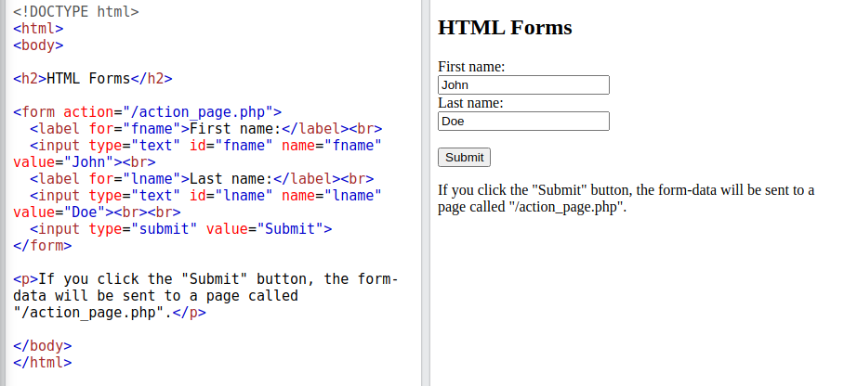

By looking at the above code and layout, write a basic UI test to fill the form and submit.

Css selector cheats

* .classname
* #id
* [attribute=value]

**Question #5:[5+7+3]**

1. What are the two ways of Defect prevention? Explain them briefly and give an example for each.
2. List all quality management principles
3. List any 3 action items to improve People Engagement principles.